LAB 07 T-TESTS & THEIR TYPES Using JASP

1. LAB OBJECTIVES
1. Understand the concept of a t-test and when it is used.
2. Perform One-Sample, Independent-Samples, and Paired-Samples t-tests using JASP .
3. Check statistical assumptions such as normality and equality of variances.
4. Interpret t-values, p-values, confidence intervals, and effect sizes.
5. Write statistical conclusions and professional lab reports.

2. INTRODUCTION TO T-TESTS
A t-test is a statistical procedure used to compare means between groups or conditions.
A t-test helps answer questions like:
Is the class average significantly different from a benchmark score?
Do males and females differ in performance?
Did students improve after training?

3. TYPES OF T-TESTS
3.1 One-Sample T-Test
Purpose: Compare the sample mean with a known theoretical value.
Example: Is the class mean different from 50?

3.2 Independent-Samples T-Test
Purpose: Compare means of two different groups.
Example: Do males and females have different test scores?

3.3 Paired-Samples T-Test
Purpose: Compare means of the same participants measured twice.
Example: Did student performance improve before vs after training?

- SOFTWARE USED:
JASP
5. EXAMPLE DATASETS
Dataset A: One-Sample T-Test
Student - Score | Score
1 | 45
2 | 55
3 | 62
4 | 48
5 | 50
6 | 58
7 | 47
8 | 54
9 | 49
10 | 60
Benchmark = 50
Dataset B: Independent Samples T-Test
Student | Gender | Score
1 | Male | 68
2 | Male | 72
3 | Male | 75
4 | Female | 80
5 | Female | 85
6 | Female | 90
Dataset C: Paired Samples T-Test
Student | Before | After
1 | 50 | 60
2 | 55 | 70
3 | 48 | 65
4 | 60 | 72
5 | 52 | 68
6 | 58 | 75

6. PERFORMING T-TESTS IN JASP (STEP-BY-STEP)
6.1 One-Sample T-Test
Steps:
Open JASP .
Upload dataset.
T-Tests → One-Sample T-Test.
Move Score into Test Variable.
Set Test Value = 50.
Enable: Descriptives, CI, Effect size, Normality test.
Sample Output:
Mean = 52.8, t(9)=1.77, p=0.110
Interpretation: Mean is not significantly different from 50.

6.2 Independent Samples T-Test
Steps:
Open JASP .
Upload dataset.
T-Tests → Independent Samples T-Test.
Dependent Variable: Score; Grouping Variable: Gender.
Enable all options.
Sample Output:
Male Mean = 71.67
Female Mean = 85.00
t = -4.12, p = 0.009
Interpretation: Females scored significantly higher.

6.3 Paired Samples T-Test
Steps:
Open JASP .
Upload dataset.
T-Tests → Paired Samples T-Test.
Pair: Before, After.
Enable all options.
Sample Output:
Mean Difference = 14.50
t = 7.12
p = 0.0006
Interpretation: Training significantly improved performance.

7. HOW TO WRITE A STATISTICAL REPORT
Example:
A paired-samples t-test showed a significant improvement from Before (M = 53.83) to After (M = 68.33), t(5) = 7.12, p < 0.001.
8. STUDENT TASKS
Task 1: One-Sample T-Test with benchmark 60.

One Sample T-Test
One Sample T-Test
 |  |  |  |  |  | 95% CI for Cohen's d
 | t | df | p | Cohen's d | SE Cohen's d | Lower | Upper
Score | 1.510 | 9 | .165 | 0.477 | 0.334 | -0.191 | 1.123
Note. For the Student t-test, the alternative hypothesis specifies that the mean is different from 50.
Note. Student's t-test.

Assumption Checks
Test of Normality (Shapiro-Wilk)
 | W | p
Score | 0.941 | .566
Note. Significant results suggest a deviation from normality.

Descriptives
Descriptives
 | N | Mean | SD | SE | Coefficient of variation
Score | 10 | 52.80 | 5.865 | 1.855 | 0.111

Descriptives Plots

Score
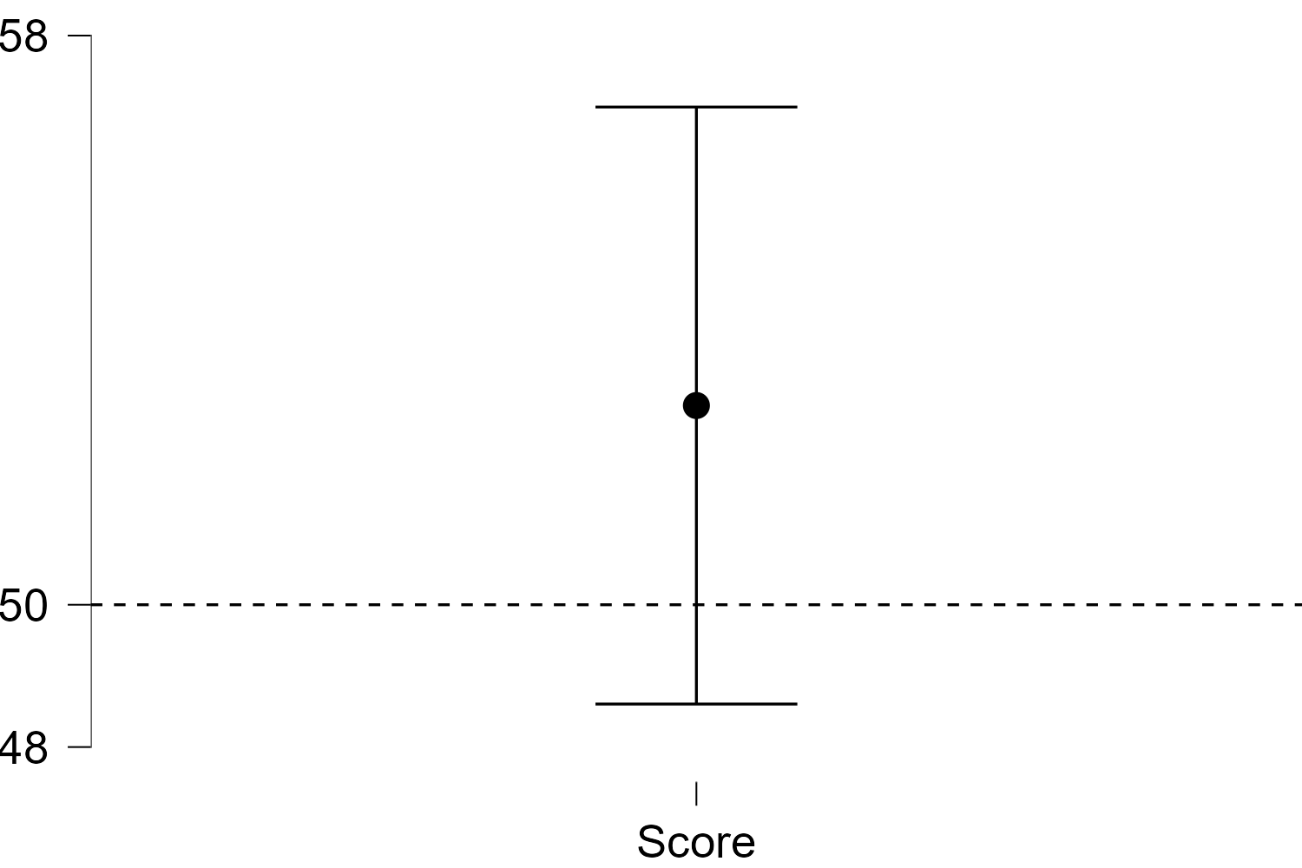

Raincloud Plots

Score
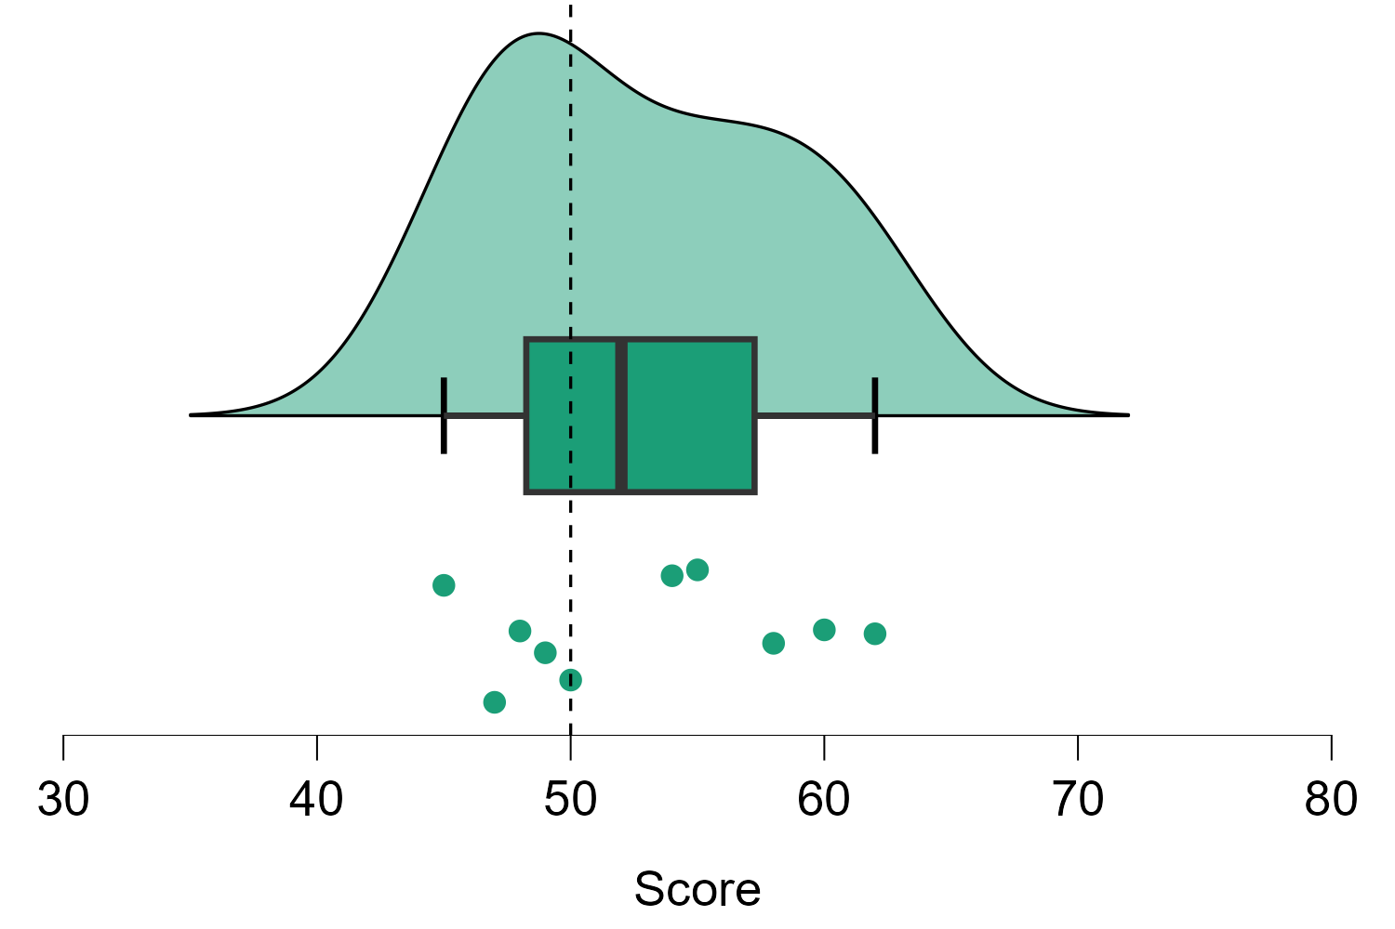

Task 2: Independent T-Test .

Independent Samples T-Test

Assumption Checks
Test of Normality (Shapiro-Wilk)
Residuals | W | p
Score | 0.950 | .744
Note. Significant results suggest a deviation from normality.

Test of Equality of Variances (Brown-Forsythe)
 | F | df₁ | df₂ | p
Score | 0.237 | 1 | 4 | .652

Q-Q Plots

Score
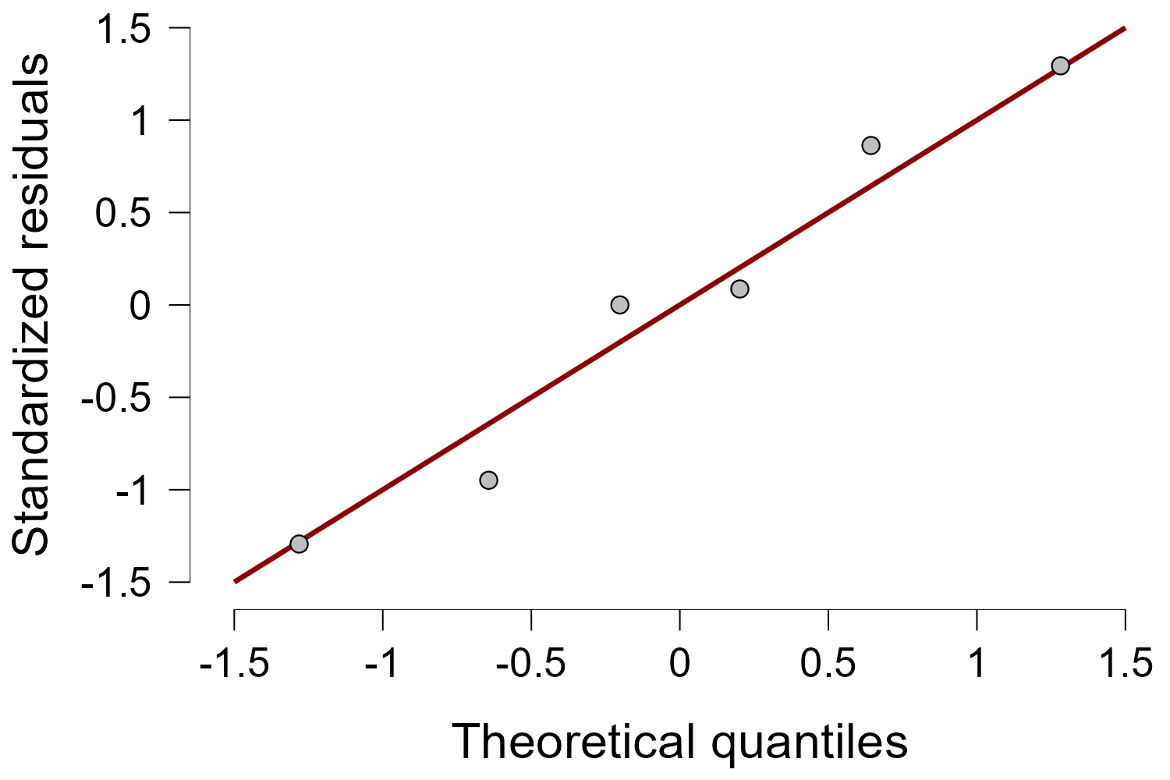

Descriptives
Group Descriptives
 | Group | N | Mean | SD | SE | Coefficient of variation | Mean Rank | Sum Rank
Score | Female | 3 | 85.00 | 5.000 | 2.887 | 0.059 | 5.000 | 15.000
 | Male | 3 | 71.67 | 3.512 | 2.028 | 0.049 | 2.000 | 6.000

Descriptives Plots

Score
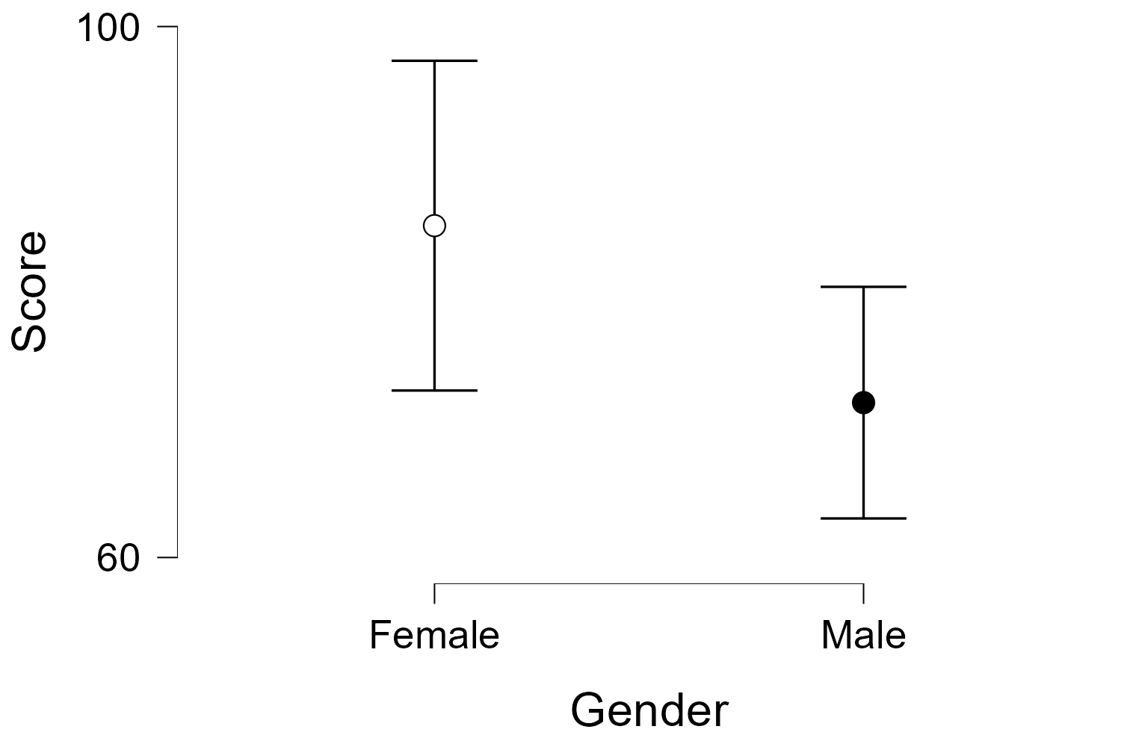

Raincloud Plots

Score
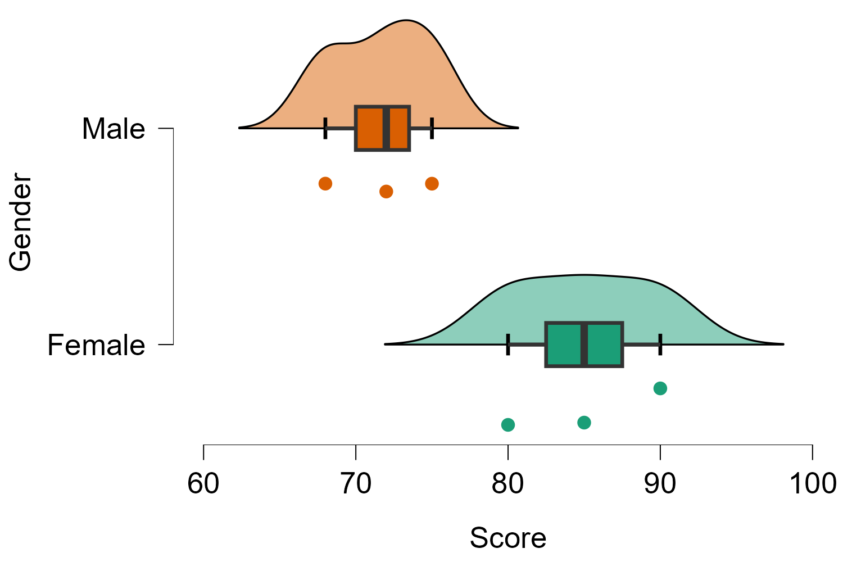

Bar Plots

Score
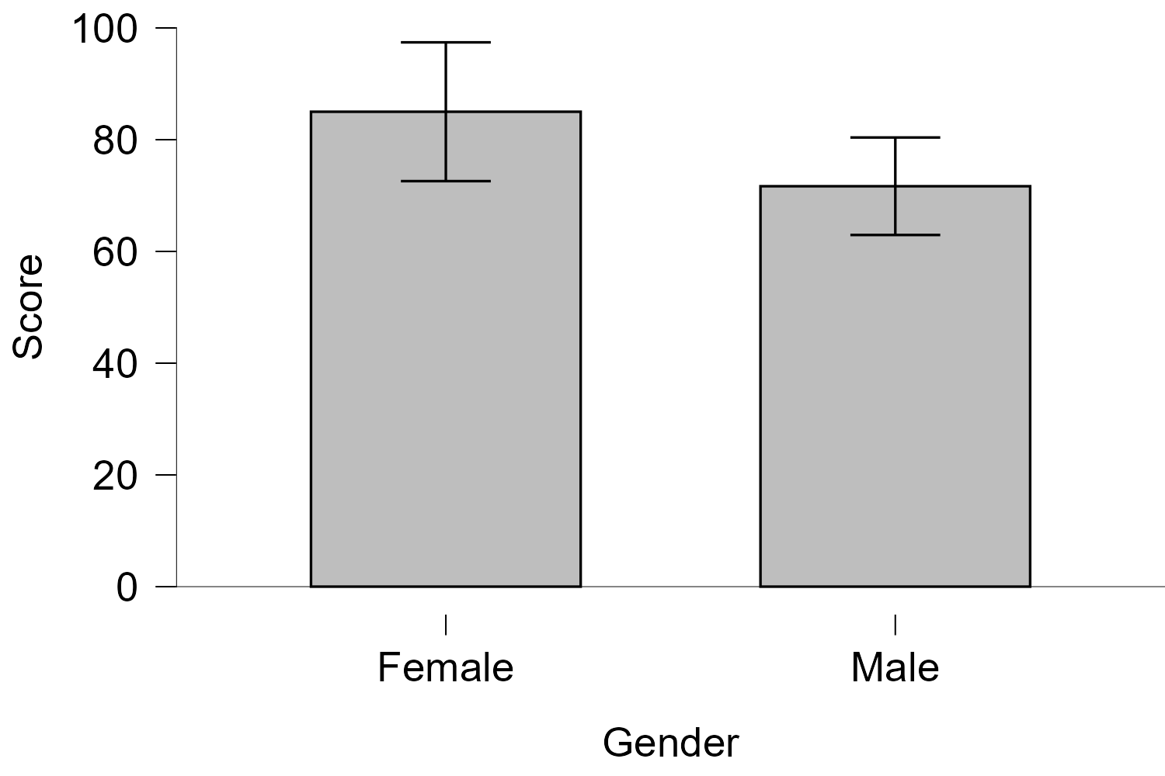

Task 3: Paired T-Test (Before vs After training).

Paired Samples T-Test

Assumption Checks
Test of Normality (Shapiro-Wilk)
 |  |  | W | p
Before | - | After | 0.865 | .208
Note. Significant results suggest a deviation from normality.

Q-Q Plots

Before - After
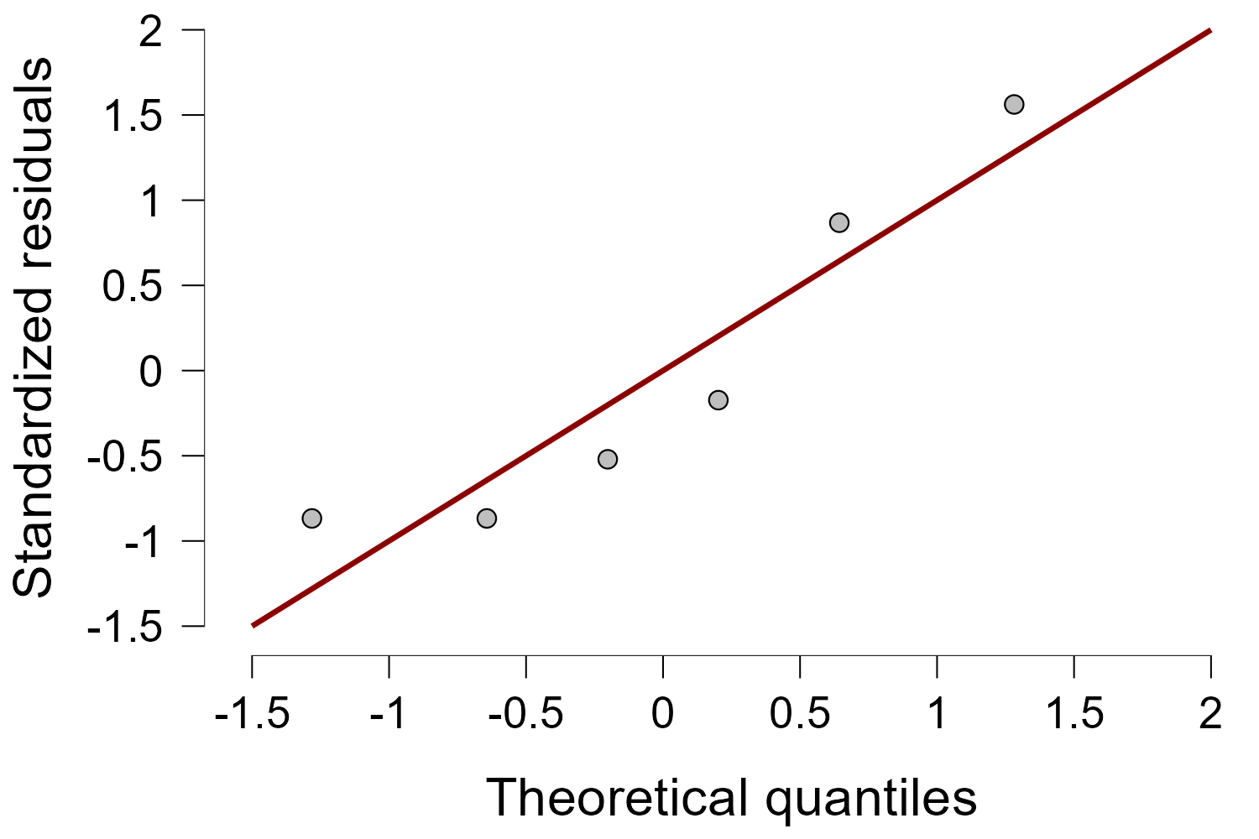

Descriptives
Descriptives
 | N | Mean | SD | SE | Coefficient of variation
Before | 6 | 53.83 | 4.665 | 1.905 | 0.087
After | 6 | 68.33 | 5.317 | 2.171 | 0.078

Descriptives Plots

Before - After
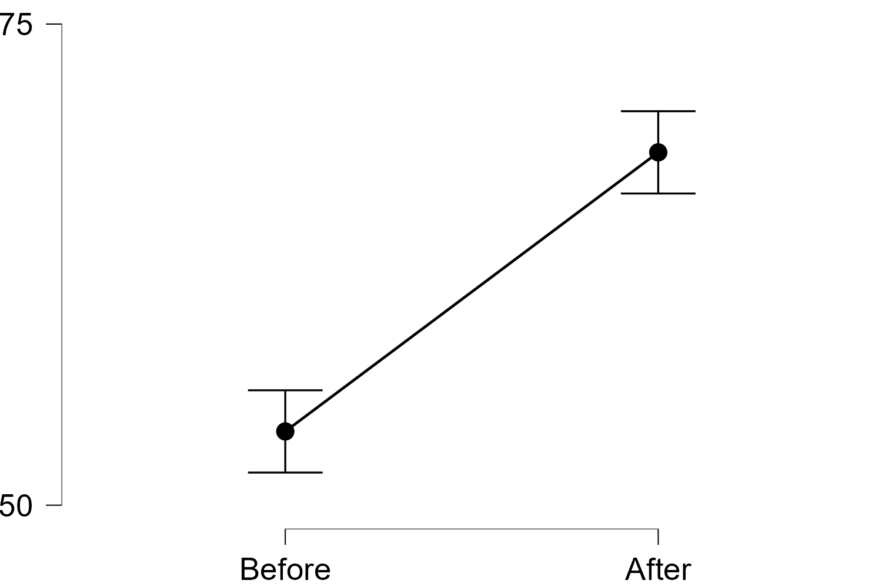

Raincloud Plots

Before - After
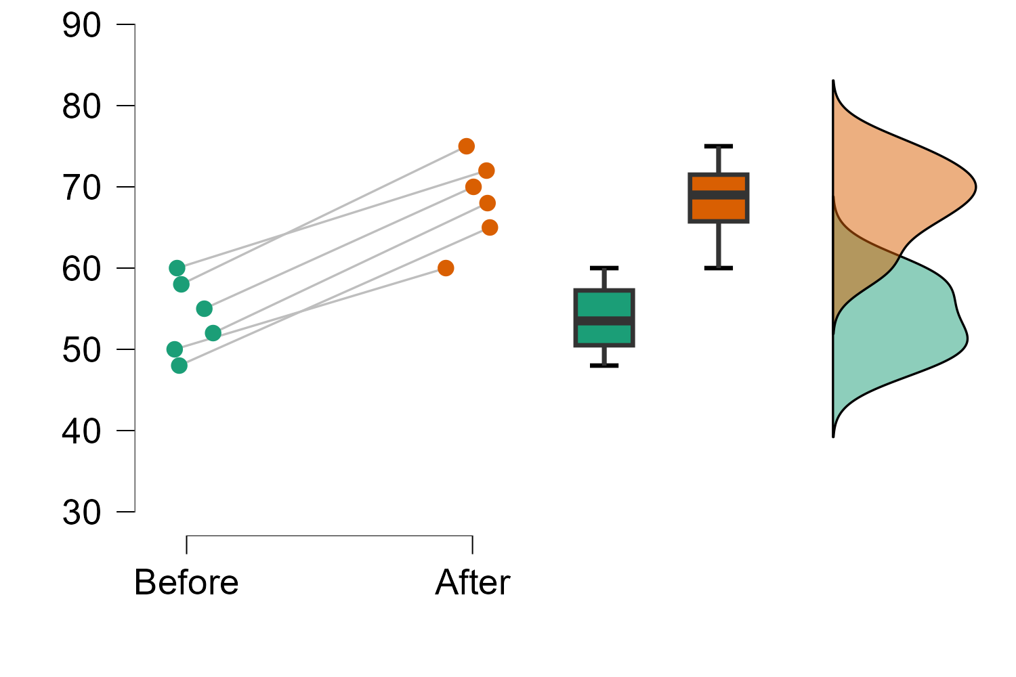

Raincloud Difference Plots

Before - After
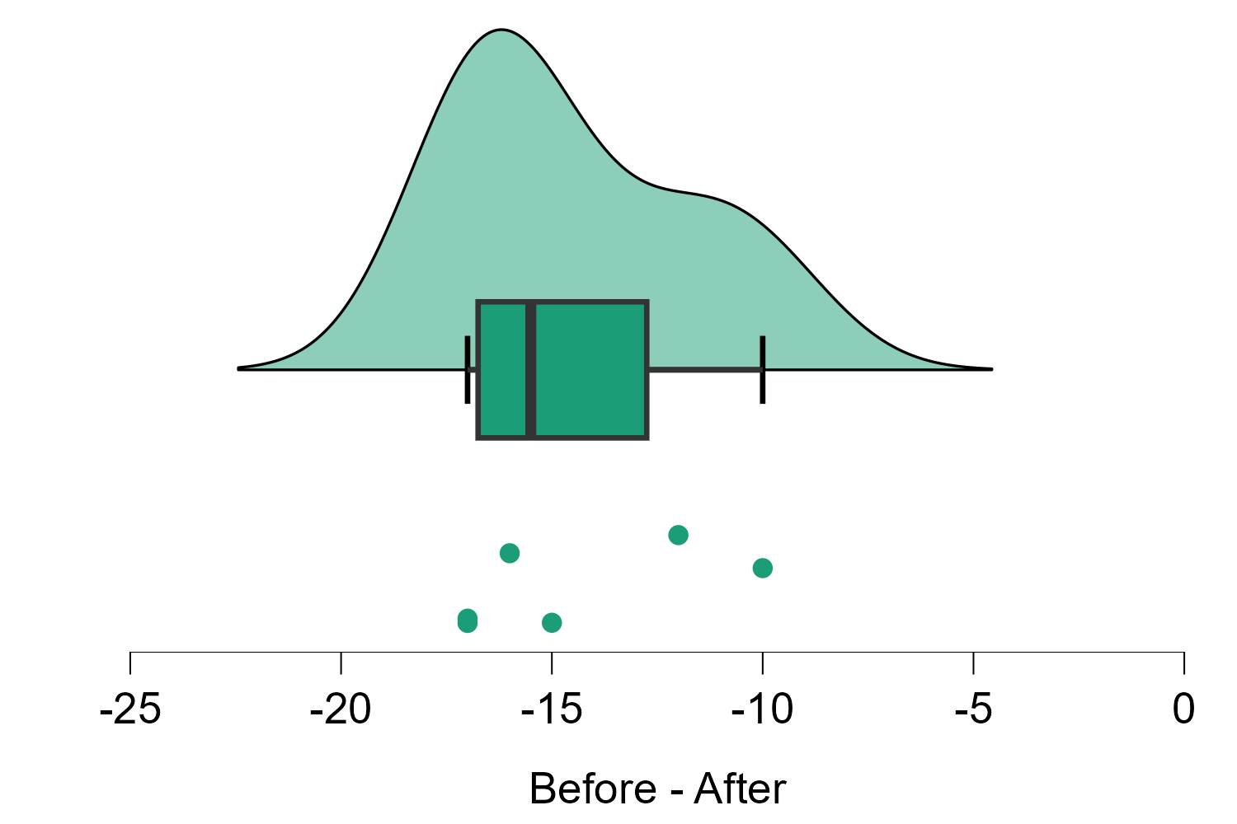

Bar Plots

Before - After
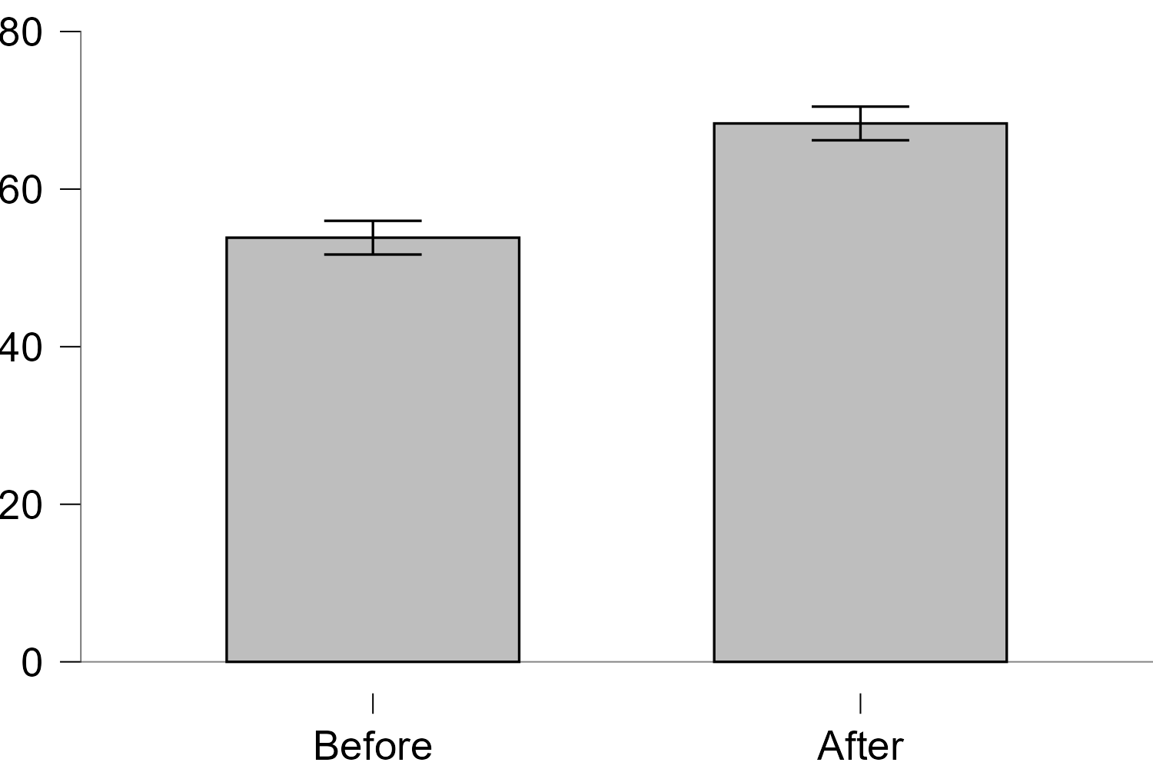

Task 4: Write one-paragraph report.

